Networking Concepts

## 1. NAT (Network Address Translation)

Translates private IP addresses to a public IP for internet access, like a receptionist forwarding internal calls to the outside world. Network Address Translation (NAT) - GeeksforGeeks

## 2. ARP (Address Resolution Protocol)

Maps IP addresses to MAC addresses in a local network, like asking who lives at a house number so you can knock on the right door.



## 3. MAC (Media Access Control) Address

A device’s unique hardware identifier on a network, like a permanent name tag that never changes.

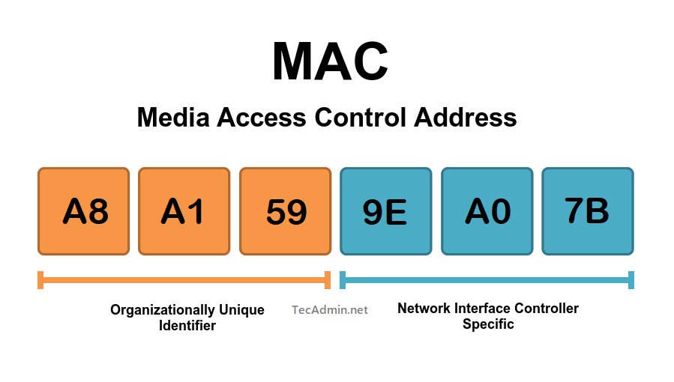

## 4. IPv4

The most common version of IP addresses (e.g. 192.168.1.1), like a home address using a street and number.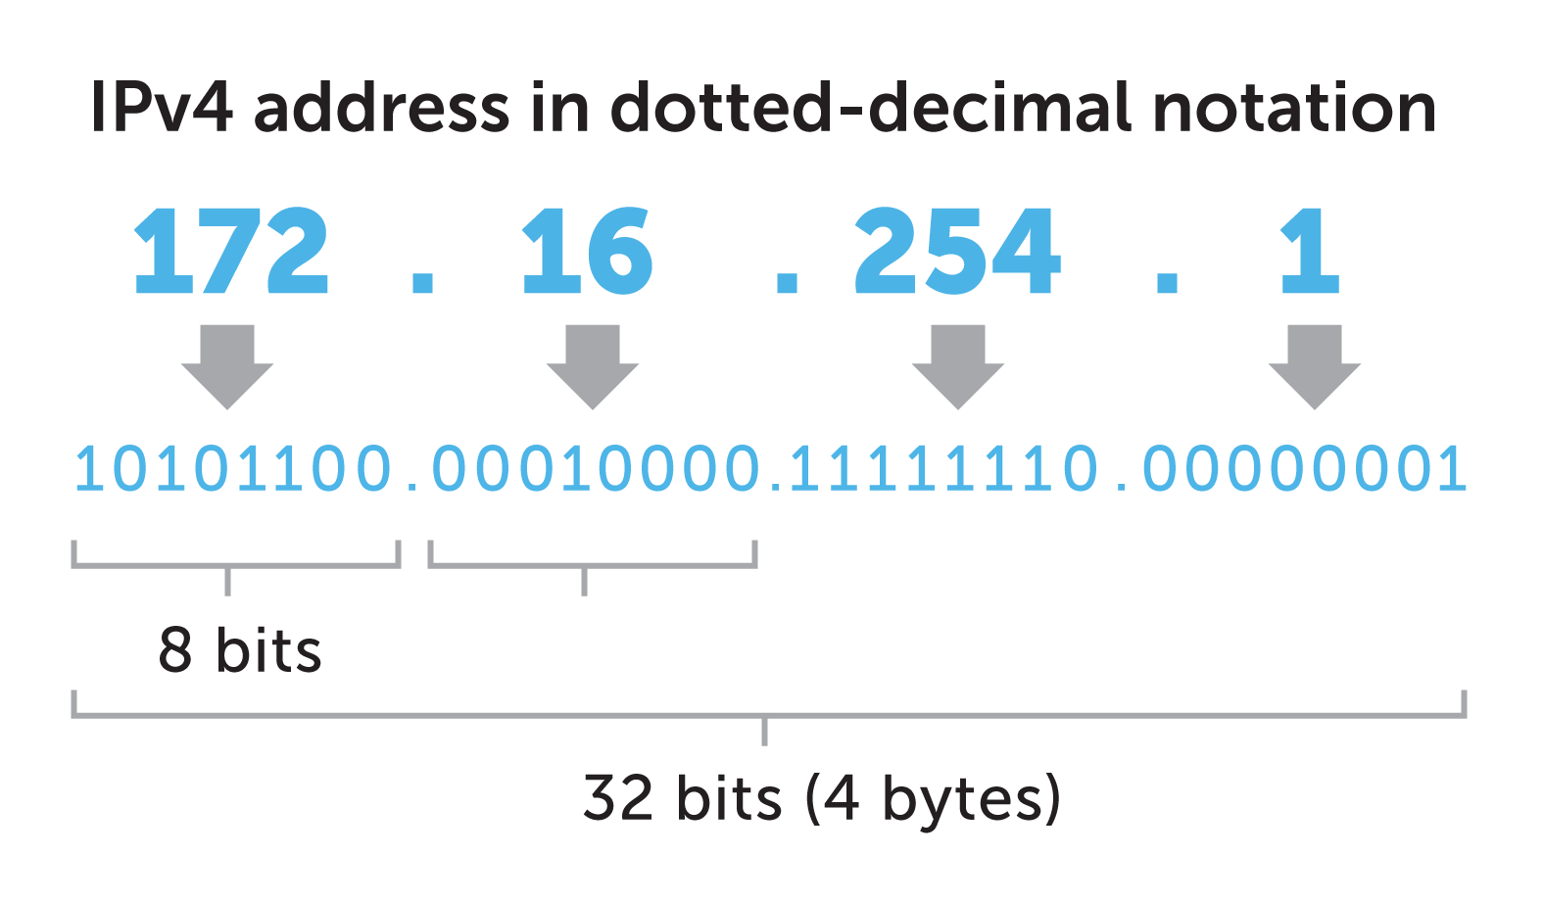

## 5. IPv6

The newer version of IP addressing with vastly more unique addresses, like a massive city with infinite homes.

